2)
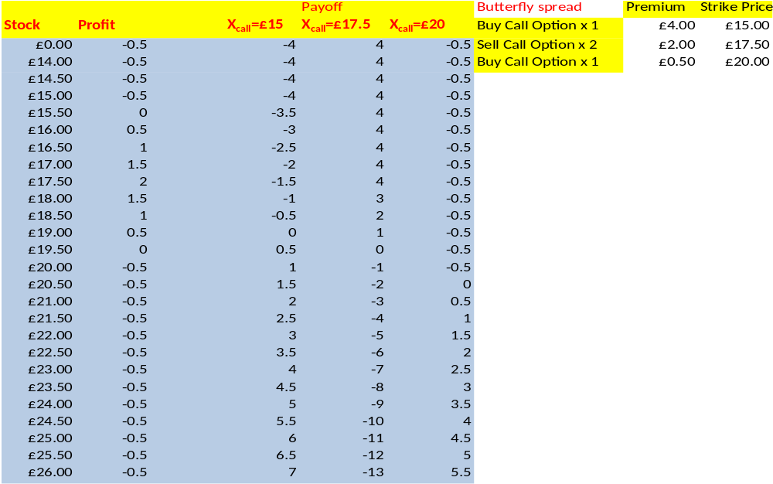

Components
Short two ATM call options, long one ITM call option and long one OTM call option.
Risk / Reward
Maximum Loss: Limited to the ATM strike less the ITM strike less the net premium paid for the spread.
Maximum Gain: Limited to the net premium received from the spread.
Characteristics
When to use: When you are neutral on market direction and bearish on volatility.
With a long butterfly your losses are limited. This means that you make money when the market remains flat over the life of the options.

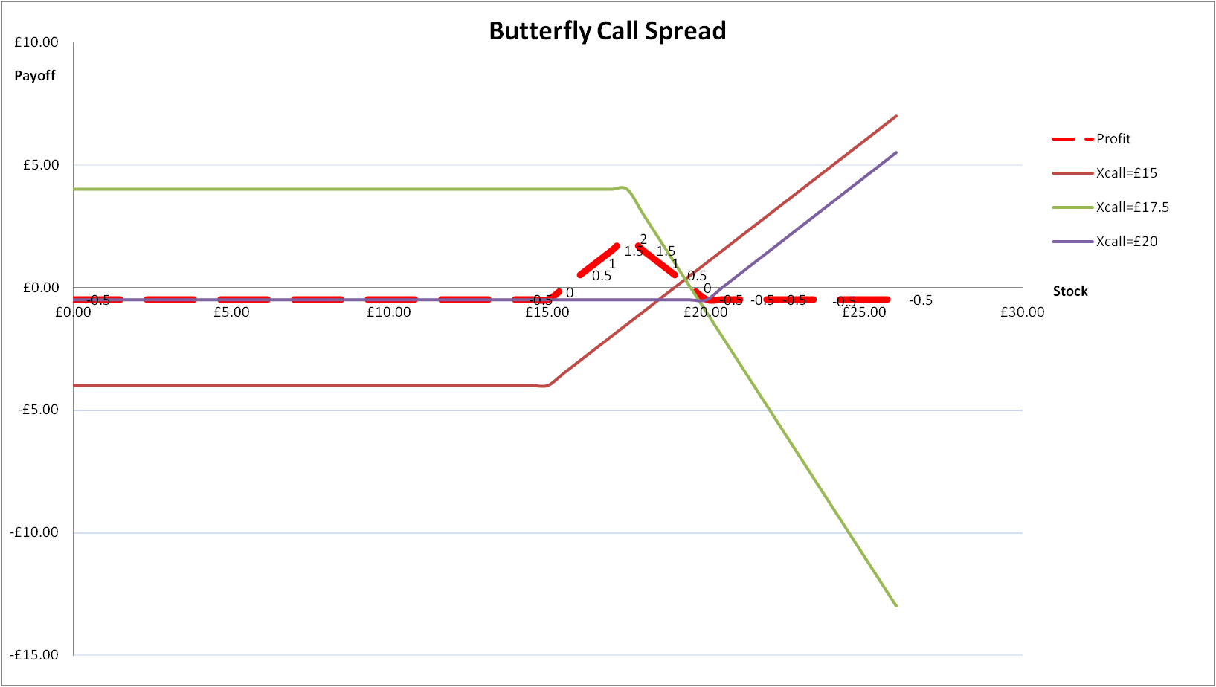

3)
